How To Debug With Eclipse And X3
Table of Contents
Introduction 3
Which Eclipse Should I Install? 3
Installing the X3 plugins 3
How To Hook Up Debugging With X3 4
Step 1: Set the X3 Parameters 4
Step 2: Set the X3 Client To Use Eclipse 4
Step 3: Create The X3 Project Inside Eclipse 5
Step 4: Set Your Eclipse Parameters 8
Step 5: Open the Specific Code You Want To Debug 10
Step 6: Place your break point. 10
Step 7: Set your Eclipse perspective to Debug 11
Step 8: Run the Action Inside X3 That Will Catch The Debug Point 11

Introduction
With Sage ERP X3 V6 you can debug source inside X3 using the Eclipse editor. To perform this task you should have some background in X3 development as well as general Eclipse and developer knowledge. Follow the steps below to complete the debugging procedure.

Which Eclipse Should I Install?
A specialized version of Eclipse is provided with the necessary components to integrate with X3 already built in. This version of Eclipse can be found on your X3 installation media. You will find a copy of this version of Eclipse within the FREECOMPONENTS directory. Once within this folder you will see an Eclipse install. You must already have Java installed on your computer for this installation to work. The contents of the FREECOMPONENTS\Eclipse folder looks like the following
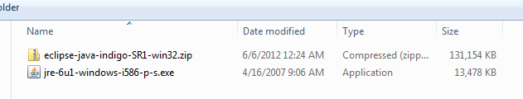

Installing the X3 plugins
Once you’ve unzipped the Eclipse studio you need to install or update the Sage X3 components. Instructions for this are provided within the Sage ERP X3 online help at the following location:
Installation > Installation and configuration of SAFE X3 Studio for Eclipse
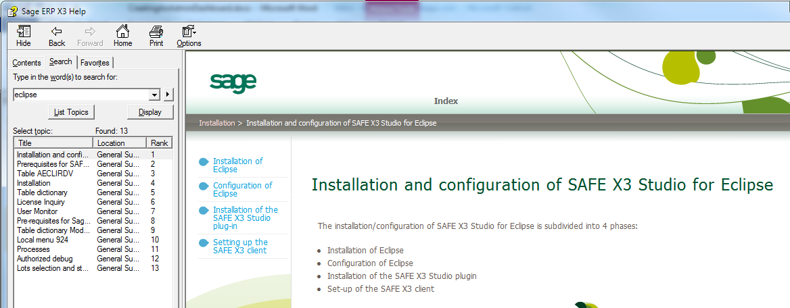

How To Hook Up Debugging With X3
A series of steps are required for you to work with Eclipse in an interactive debug session. Perform the following for this to work. Note, these particular instructions are for debugging on the same machine as the application server. More complex set ups can be taken into account with remote debugging, but that is outside the scope of this guide.

Step 1: Set the X3 Parameters
You must set X3 parameters like the following:
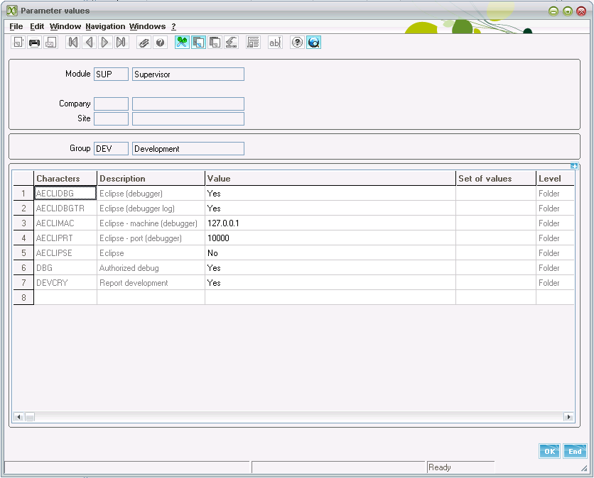

Step 2: Set the X3 Client To Use Eclipse
From the Sage ERP X3 client menu bar at the top click on Tools then options. Next, navigate to the SAFE X3 Studio tab and point to your X3 installation directory.
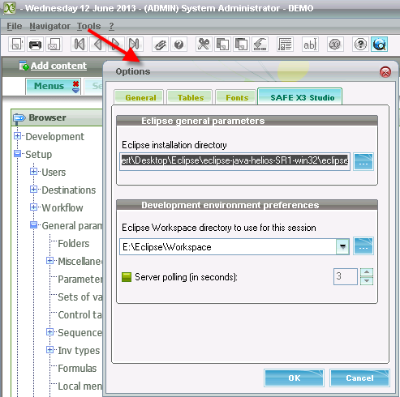
Note, you should already have a workspace created in Eclipse before setting the workspace above. To do this simply launch Eclipse once.

Step 3: Create The X3 Project Inside Eclipse
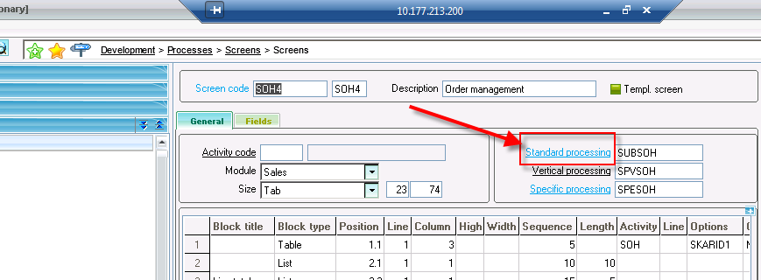
Launch GESAMK, the screen dictionary and find the screen code SOH4. Next, click on the Standard processing button to easily being the wizard process inside Eclipse.
You will be presented with a screen to launch launch a new project wizard inside Eclipse:
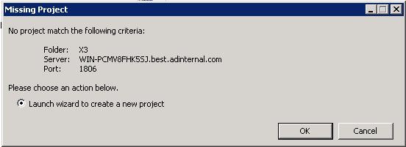

When presented with this screen click next:
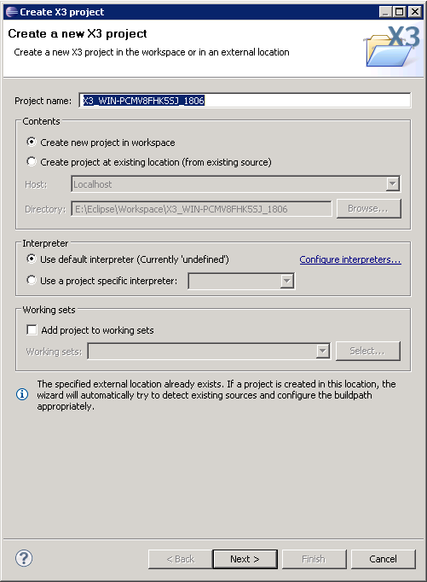

Click next again to get to the Sage X3 project properties screen and fill in the necessary information. Note, in the screenshot below the port is the runtime port, and the folder is the specific folder you want to connect to. In addition, the X3 user should be one that has the development parameter to allow debug turned on and the server authentication should be a windows administrator. When you are done click the “Check connection” button to verify your connection is set properly then click finish.
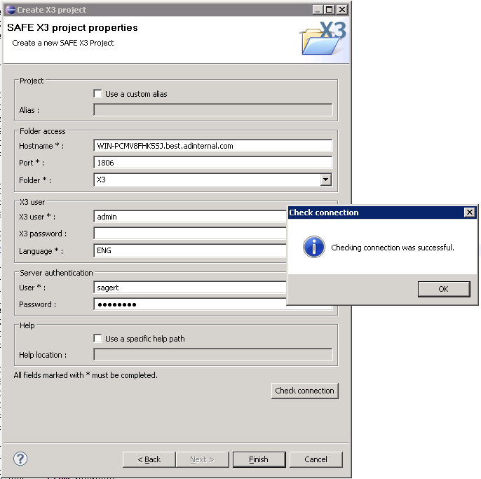

Step 4: Set Your Eclipse Parameters
You should also set the user parameters inside Eclipse. To do this click on the Project | User parameters button from the menu bar:
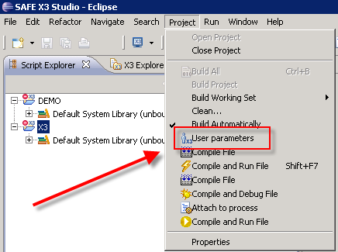

Set the properties as follows:
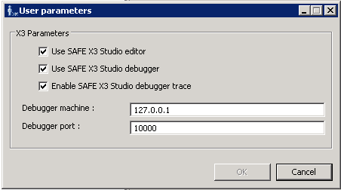

Step 5: Open the Specific Code You Want To Debug
To open an X3 source file click on the File | Open SAFE X3 Source File on the menu bar at the top:
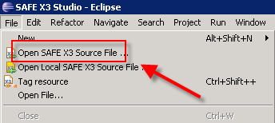
You will then be presented with a file browser which you can filter with.
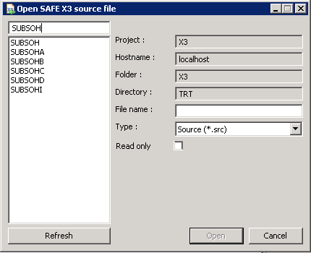
Pick your source file you want to debug inside, then click open.

Step 6: Place your break point.
In this case, we’ve opened our SUBSOH file and then using the F3 button, we’ve opened the declaration to the Creation subroutine within SUBSOHA. Now that we’re inside SUBSOHA we’ll place a debug point using X3’s debug directive “Dbgaff” as shown below:
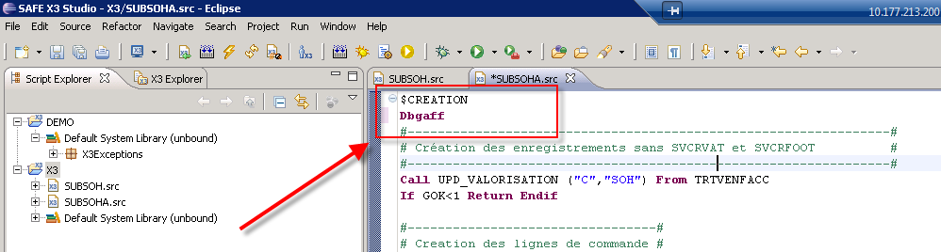
You’ll then click the compile button within Eclipse. This is the same compile button that the normal X3 Process Editor has.
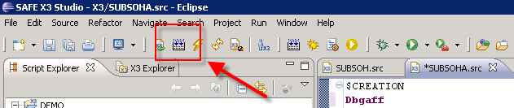

Step 7: Set your Eclipse Perspective to Debug
Next, you must set your debug perspective. This button is usually on the top right hand corner of the Eclipse, as shown below:
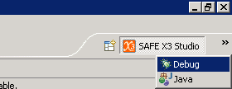

Step 8: Run the Action Inside X3 That Will Catch the Debug Point

